Name: Marking key |  | Date:
 | Year 7 Mathematics  Term 3, 2021  Test: Algebra and Graphing  Resources Allowed:  - 1 piece A4 paper notes  - Pens, pencils, ruler | Total Marks:

Question 1 (4 marks)
Use the following words to complete the sentences below.

equation, LHS (left hand side), expression, RHS (right hand side)

- An expression is a collection of pronumerals, numbers and operators without an equal sign.
- An equation is a mathematical statement stating that two things are equal.
- Equations have a LHS and a RHS and equals sign in between.

Question 2 (4 marks)
Draw a line to match the statements in their simplest form.
- 4 more than k 4m
- 4 lots of m y - 7
- Y decreased by 7 4 + k
- The product of 5 and the result of the sum of 4 and double x 5(4 + 2x)

Question 3 (4 marks)
Simplify the following by collecting like terms:
- 3b + 7b + 4 10b + 4
- 4x + x – 2x + 2y 3x + 2y
- 3 + 6xy + 3xy – 2 3 + 9xy – 2
- 7a + 4a + b + b + a 12a + 2b

Question 4 (4 marks)
- If a = 5 and b = 4, what is the value of 3a + 2b?
3a + 2b
= 3(5) + 2(4)
= 15 + 8
= 23
- If x = 2, what is the value of 4x + 7?
4x + 7
= 4(2) + 7
= 8 + 7
= 15

Question 5 (6 marks)
Solve each of the following equations. (show all working)
- a – 3 = 7  +3. +3  a = 10 | - 5d – 4 = 46  +4 +4  5d = 50  /5 /5  d = 10
- 3 + (x-6) = 5  x-3 = 5  X = 8 | - 35 = 7c  /7 /7  C = 5
Question 6 (6 marks)
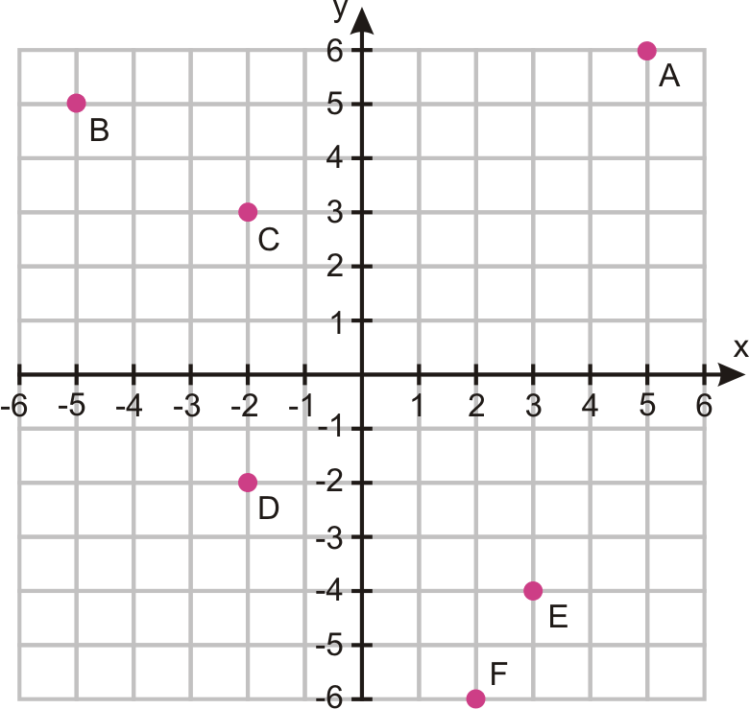
Identify the points of the coordinate plane below.

A: (5, 6)
B: (-5, 5)
C: (-2, 3)
D: (-2, -2)
E: (3, -4)
F: (2, -6)

Question 7 (2 marks)
Using the table of values below, plot the points on the graph and draw a line through the points.
Y = 2x + 1
X | 1 | 2 | 3 | 4 | 5
Y | 3 | 5 | 7 | 9 | 11
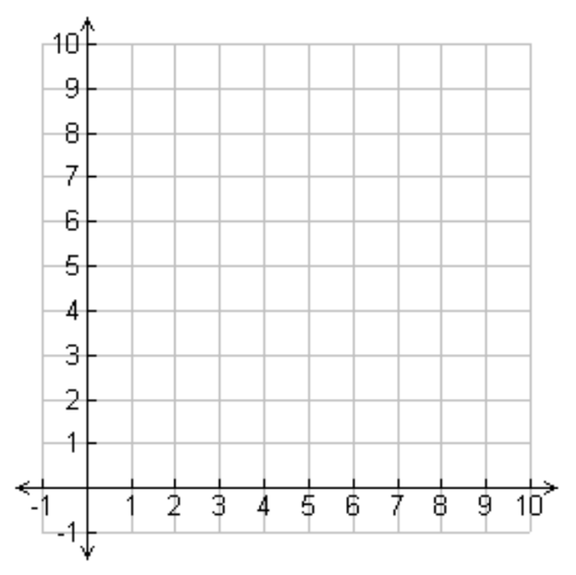

√ Plotting the points
√ Drawing a line through the points

Question 8 (4 marks)
Fill in the missing numbers from the table of values using the rule below.
Y = 2x + 4
X | 1 | 2 | 3 | 4 | 5
Y | 6 | 8 | 10 | 12 | 14

Using the table of values, plot the points on the graph and draw a line through the points.
√ Plotting the points
√ Drawing a line through the points
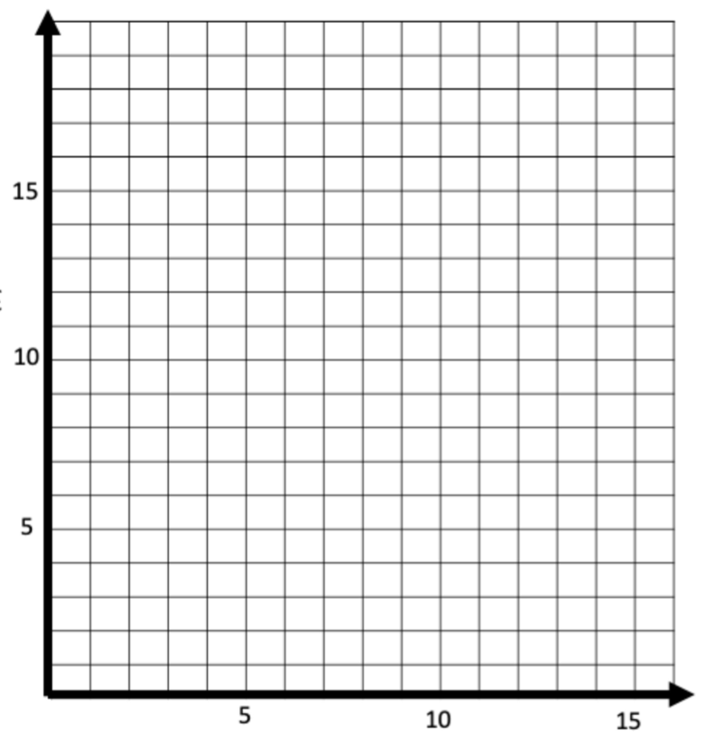

End of test

